LOANS
TABLE OF CONTENTS

1 Indirect Loans 4
1.1 The Deal (proposal) stage 4
1.2 The Disbursement Stage 4
1.3 The Loan repayment 4
1.4 Advantages and Key features of Indirect Loans 5
1.5 Disadvantages 5
2 Demand loans (Bridge Financing) 6
2.1 Definition 6
2.2 Scenario 6
2.3 CASPER Navigation 7
3 Time Loans 8
3.1 Wrong Scenario 8
3.2 Correct Scenario 9
3.3 Why banks charge Prepayment Penalty? 9
3.4 Difference between a Demand Loan and a Time Loan 10
4 Installment Loans 11
5 US Libor Advances 12
5.1 How LIBOR is calculated 12
5.2 LIBOR Loans (Advances) 12
5.3 Rate Cap 12
5.4 Characteristics of LIBOR Loans: 13
6 Personal Loan Variable Rate 14
6.1 RB Prime 14
7 Royal Credit Line 15
8 Banker’s Acceptance 16
8.1 Definition 16
8.2 Scenario 18
8.3 Associated Risks 20
8.4 References 21
9 RoyFarm Mortgage Multiple Loan 22
9.1 Brief Overview 22
9.2 Targeted Customers 22
9.3 Features 22
9.4 Benefits 23
10 RBOL 24
10.1 Purpose of the Loan 24
10.1.1 Description of Loan 24
10.2 Benefits of RBOL 25
10.3 Eligibility 25
10.4 Rate of Interest and Other Charges 26
10.5 Additional Information 26
10.6 Referance 26
11 . Loans to Cities, Towns, Municipalities, etc 29

Indirect Loans

An indirect loan is a loan which is not applied by the individual taking the loan. The loan is applied by another institution on behalf of the actual client who will be repaying the loan. Consider the following example:

The Deal (proposal) stage
Borrower
Automobile Company
Bank 1 – various proposals from the bank based on the Amortization, Interest rate type etc
Bank 2 – various proposals from the bank based on the Amortization, Interest rate type etc

Bank 3 – various proposals from the bank based on the Amortization, Interest rate type etc

The Disbursement Stage

Automobile Company
Bank 2 – The Loan amount is disbursed to the Automobile Company.

The Loan repayment
The EMI (Equal Monthly Installments), Principal and Interest payments are paid by the Borrower (the individual) to the bank according to the terms and conditions agreed upon (proposal).
Bank 2
Borrower

As we can see from the above diagram, the Individual does not approach the Banks directly for the loan. The Institution (Automobile Company) approaches the bank for the loan. The Loan amount (the price of the automobile) is paid to the Institution, but the repayment is made by the individual, hence, the name Indirect Loan.

Advantages and Key features of Indirect Loans
- The borrower does not have to take the burden of going to different lenders for the loan. The institution would provide a portfolio of loan options to choose from.
- Since the institution would be in a constant touch with the bank, the process of disbursing the loan would be quicker

Disadvantages
- The interest rates charged on such loans are generally more than the normal Personal Loans and Auto Loans. The higher interest rate is explained by the extra services that the bank offers the borrower for making this loan.

Demand loans (Bridge Financing)

Definition

Demand loans are used for short-term situations (typically no more than 180 days) where the client has money coming at a later date to repay the loan (bridge financing). Short Term Financing involves situations where the client is expecting to receive money (usually within a year), and repayment is to be sourced from these funds.

Generally Demand loans are loans with no specific maturity date, but payable at any time the lender demands. Only interest is paid until the principal is paid off, or until the lender demands repayment of principal. The borrower may, however, pay off the loan early, without incurring a prepayment penalty. Demand loans may be unsecured or secured.

Scenario
When a client has purchased a new property and has sold their existing property but the new purchase closes prior to the sale the client may require short term financing (bridge financing) in the form of a demand loan until the sale closes. Bridge financing can be provided in these situations provided the client has unconditional offers of sale and purchase for both properties. Once the client’s existing property sale has closed, the bridge financing demand loan will be paid out from the proceeds of sale. Bridge Financing will only be funded providing the residential mortgage or Home line is being funded through RBC.

- Demand loans are not eligible for Loan Protector insurance coverage.
- Documents to be included are:
- Completed Interim Financing Worksheet
- All the pages of Unconditional Sales Agreement together with subject removal document
- Purchase Agreement

RCL/Demand Loan are linked to the authorized credit (Authorized Credit (A/C) is a system that is in conjunction with the OLBB Loan system.) segment, which monitors loan balance. The expiry date of the Authorized Credit must be set for the date that the funds are expected to pay out the loan. Personal Demand loans are only available as variable rate loans based on the Royal Bank Canadian Prime rate (RBP) with payments of interest only.

CASPER Navigation

Proposal Screen:

- Proposal Type: RCL/Interest Only
- Rate Type / Int Method: RB Prime and Interest Only
- Service Type: Demand Loan – Personal

Time Loans

Time loans are similar to term loans, where-in the borrowed amount is paid back in full before a specified maturity date. Generally the maturity date for time Loans would be short term (30 to 180 days).
The interest that the borrower owes to the bank is discounted before the disbursement. The borrower pays the principal amount on or before the specified maturity date.
For Example:
On 1 Jan, 2010 the borrower takes a time Loan. With the loan details as below
Proceeds – 100000
Interest Rate – 12% pa
Maturity Date – 1 year (Jan 1, 2011)

Wrong Scenario

The Loan amount disbursed to the borrower = 100000 – (100000*.12) = 88000
The Amount that the borrower owes to the bank on Maturity = 100000

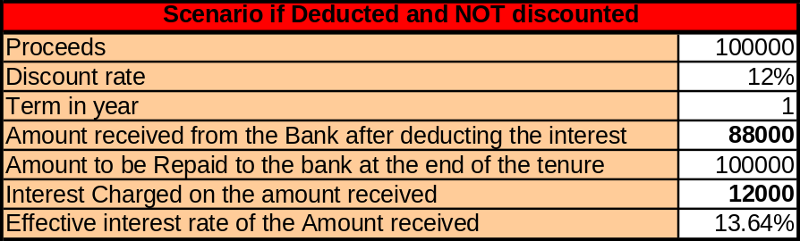

Effective rate of interest = 12000/88000 = 13.64%.
As noted above the customer pays 13.64% as interest and not 12% as disclosed by the bank earlier

Correct Scenario

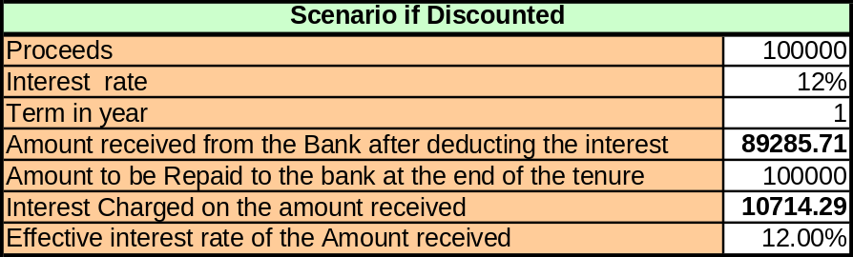

The Loan amount disbursed to the borrower = 100000/ (1+ 12%) = 89285.71
The Amount that the borrower owes to the bank on Maturity = 100000
Effective interest Rate = (100000 - 89285.71)/( 89285.71) = 12%
The workouts for the above mentioned scenarios are as below



Why banks charge Prepayment Penalty?

Banks manage their Assets and Liabilities. When the customer prepays, the bank has cash that are potential earning assets. But because such payments cannot be deployed (lent) immediately after repayment, the banks face reinvestment risk. The bank may not be able to reinvest the amount and hence lose out interest that it would have earned if it was not pre-paid (Opportunity Cost). To discourage such a scenario and to regularize the payment and repayment schedule, banks levy prepayment penalty.

Similarly, even a pre-closure of deposits also attract a similar penalty, because to return the deposit before the maturity date, the bank would be losing out on the income that it enjoys currently from its investments. Also in some cases, they might have to arrange for funds to repay the Deposit amount. So the bank transfers the opportunity cost to the customer.

Credit Cards and Prepayment –
For Credit Cards there is no charge for prepayment. This is because the inherent risk of default is high in Credit cards. The Charges levied on the default in Credit Cards is heavy. Banks earn heavily on customers who default on Credit Card payments and end up paying the Heavy penalty charges.

Difference between a Demand Loan and a Time Loan

- In a Demand Loan banks reserves the right to demand the repayment of the loan at any time. The borrower is liable to pay the bank on demand, even before the maturity date.

- For a Time Loan the bank cannot ask the borrower the repay the loan before the maturity date. But the borrower can opt to repay a part/full of the loan before the maturity date without any prepayment penalty.

Installment Loans
Loans that are repaid in the form of predetermined, periodic equal installments are called as Installment loans. The most common installment loans are mortgages. According to the interest rate and the amortization, an amortization schedule is agreed by the borrower with the lender.
There are 2 components attached to the periodic payment,
- Part of the principal being repaid
- The interest payable on the remaining balance.
The schedule is prepared in such a way, that the payment is equal for each period and the balance remaining at the end of the amortization is zero.
The factors that are used to determine the equal installments are:
- Proceeds (The amount of Loan taken)
- The amortization period
- The Interest Rate (Depends on the Market and the credit rating of the client)
- The payment type (Monthly, Quarterly, Yearly etc)

An example of the amortization schedule in the spread sheet below:

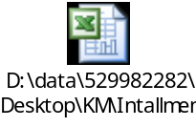

US Libor Advances
Loans (advances) that are priced according to the prevailing interest rates in the market (LIBOR) are called Libor Advances.
LIBOR stands for London Inter Bank Offer Rate. LIBOR is the interest rate at which banks borrow unsecured funds from other banks in the London wholesale money market (or interbank market). LIBOR is used as the index to price various derivatives like interest Rate Swaps, Futures etc.
The LIBOR in UK is very similar to the Prime Rate in US. The LIBOR is used in various markets directly or indirectly around the world for pricing loans and other financial instruments. LIBOR is the common index used for Mortgage Lending purposes.

How LIBOR is calculated
Everyday between 11:00 am to 12:00 pm, information is collected from 16 banks in the UK to calculate the LIBOR interest rate, which is composed of the Deposit rates. The data is averaged out and the LIBOR rate is determined on a daily basis.

LIBOR Loans (Advances)
LIBOR is used to determine the interest rate on many corporate loans, mortgages and student loans. As the LIBOR rate changes, these loans can become more costly or cheaper as LIBOR rate represents the costs of funds fort these banks.
The period for which the interest payable will be reset is agreed upon between the 2 parties at the beginning of the proposal itself. It could be either monthly, quarterly, half yearly or annually. An example of a repayment schedule is as follows:
Note: Only the interest component is reset every period. The principal is exchanged at the end of the amortization. Hence this is not an Installment Loan.

Rate Cap
When the LIBOR rate is agreed upon, a Rate Cap can also be agreed upon by the bank and its customers, to protect the interest of the borrowers. If the settlement interest rate increases more than the rate cap agreed upon, the borrower would pay only the amount applicable for a Rate Cap.
A sample settlement is demonstrated in the excel sheet below.


Characteristics of LIBOR Loans:
The Libor loan also contains some unique features:
- Initial Interest Rate- The initial interest rate will stay constant for six to ten months, kind of like how an ARM (Adjusted Rate Mortgage) would work.
- Adjustment Period- After the initial months of the constant interest rate, the interest rate will change depending on the market.
- Rate Caps- A rate cap will limit how much an interest rate can change. They usually consist of: 1% for 6 months, 2% on 1-2 years, and over 5% if longer then 7 years.
- Attractive Buy downs- If you take out a long Libor you can usually buy down the interest rate, kind of like buying discount points.
- Negative Amortization does not exist on a Libor.

LIBOR loans are opted for by the borrowers, who expect the Market interest rates to decrease over the duration of the loan. Market practitioners take such stands depending on various economic parameters. Since the actions of a central bank is in alignment with the economic parameters, inflation, expected inflation, money supply in the economy, repo rate, Prime Lending rate etc are taken as key parameters to predict the movement of interest rate. So depending on the view of the borrower about the future interest rate movement, he/she either can opt for a variable rate or fixed rate loan.

Personal Loan Variable Rate
LIBOR rate is agreed upon, a Rate Cap can also be agreed upon by the bank and its customers, to protect the interest of the Borrowers. If the settlement interest rate increases more than the rate cap agreed upon, the borrower.
Market practitioners take such stands depending on various economic parameters. Since the actions of a central bank is in alignment with the economic parameters, inflation, expected inflation, money supply in the economy, repo rate, Prime Lending rate etc are taken as key parameters to predict the movement of interest rate. So depending on the view of the borrower about the future interest rate movement, he/she either can opt for a variable rate or fixed rate loan.

RB Prime
Bank of Canada sets the Prime Lending Rate (PLR) for banks. The Prime lending is the rate a which the banks lend to its most credit worthy customers. Generally, the PLR is nothing but a minimum spread attached to the cost of funds by the bank. According to the credit worthiness of the customer taking a loan the Spread will be increased or decreased.
RB Prime is the Prime Lending Rate of Royal Bank of Canada. The bank attaches its spread to the Prime rate set by Bank of Canada to arrive at this figure.
RB prime is also linked to the LIBOR which is considered to be a Global index for interest rates.

The terms and conditions applicable for a Variable Rate loan is similar to the US LIBOR Advance as discussed in the section earlier. The only difference being the interest rate taken into consideration would be the Prime Rate set by Bank of Canada and the RB Prime (for RBC).



Royal Credit Line
Royal Credit Line is a Credit Line offered to the Royal Bank Customers. The Credit Limit needs to be Authorized before it is applicable. The Limit is set according to the Credit worthiness of the client, earning and repaying capacity etc.
Royal Credit Line is in principle very similar to a Credit Card. For a Credit Card, the duration is much shorter. The amount has to be repaid in a month for a Credit Card. The default on such Credit Card payments attracts heavy charges. In a RCL the customer has the liberty to take a loan for any purpose and different tenures. The only constraint would be the Credit Limit.
For E.g.: A Customer having a RCL Credit Limit of 20000 can take 4 Loans of 5000, each for a different tenure (1 year, 5years, 3 years, 2 years etc). The rate is fixed every year on the outstanding balance. Since the interest Rate is reset every year/period, Fixed Rate Loans are not applicable in RCL. Loans under RCL are always Variable Rate (RB Prime).
RCL can be Secured and Unsecured. Since the risk associated with a Secured loan is always considered to be less risky, Loans under a Secured RCL attract marginally lesser Interest Rate.
Below is a sample Excel sheet showing the calculations for an RCL. The interest Rates for the various terms are assumed for simulation.
The Assumptions are:
- The New Loan is always taken at the beginning of the year.
- The Principal part of the Loans is always paid back at the end of the year.



Banker’s Acceptance

Definition

Bankers Acceptance is a short term obligation issued by a schedule 'A' bank in Canada not to exceed 364 days in duration. In other words a banker's acceptance (BA) is a short-term credit investment created by a non-financial firm and guaranteed by a bank to make payment. The bank, as drawee of the draft, indicates its acceptance of the obligation by stamping the word "accepted" on the face of the draft, dating and signing it. By accepting the draft, the bank signifies its commitment to pay the stated amount of the draft on a specified future date. The company for whom the draft is accepted (drawer) may have the draft held until maturity to collect the full amount, or may discount the acceptance and collect immediate payment, less applicable discount rate.

Underlying obligations of Bankers' Acceptances are loans made to corporations, stamped and fully guaranteed by the Royal Bank of Canada. Acceptances are traded at a discount from face value on the secondary market.

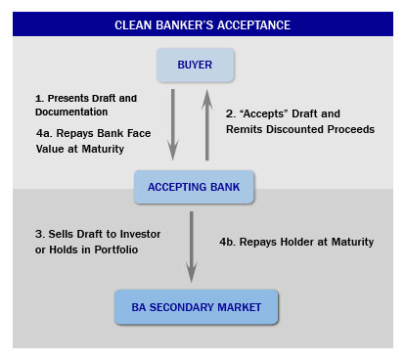
Fig -1 Flow diagram of Bankers Acceptance
Banker's acceptances are very similar to T-bills (Treasury Bills) and are often used in money market funds. Bankers' Acceptances settle in the DCS (Debt Clearing system). They trade at a spread over T-bills. The rates at which they trade are called bankers acceptance rates (or BA rates). These rates incorporate appropriate credit risks, liquidity risks, market volatility and reflect the rates at which traders of RBC Dominion Securities would be prepared to buy BA’s issued by leading Canadian Banks for specific terms to maturity.

Canadian Dealer Offered Rate (CDOR) is the average rate for Canadian bankers' acceptances (stamped by a leading Canadian bank) for specific terms-to-maturity, determined daily at or around 10am EST from a survey on bid-side rates provided by the approved principal market-makers, including the major Canadian banks. CDOR provides the basis for a floating reference rate in Canadian-dollar transactions analogous to LIBOR. CDOR serves both money and derivative markets: it is employed for the final settlement price for the BAX futures contracts as well as for the OTC derivatives market synthetic instrument calculations like FRA’s (Forward Rate Agreement) and swaps.

Scenario
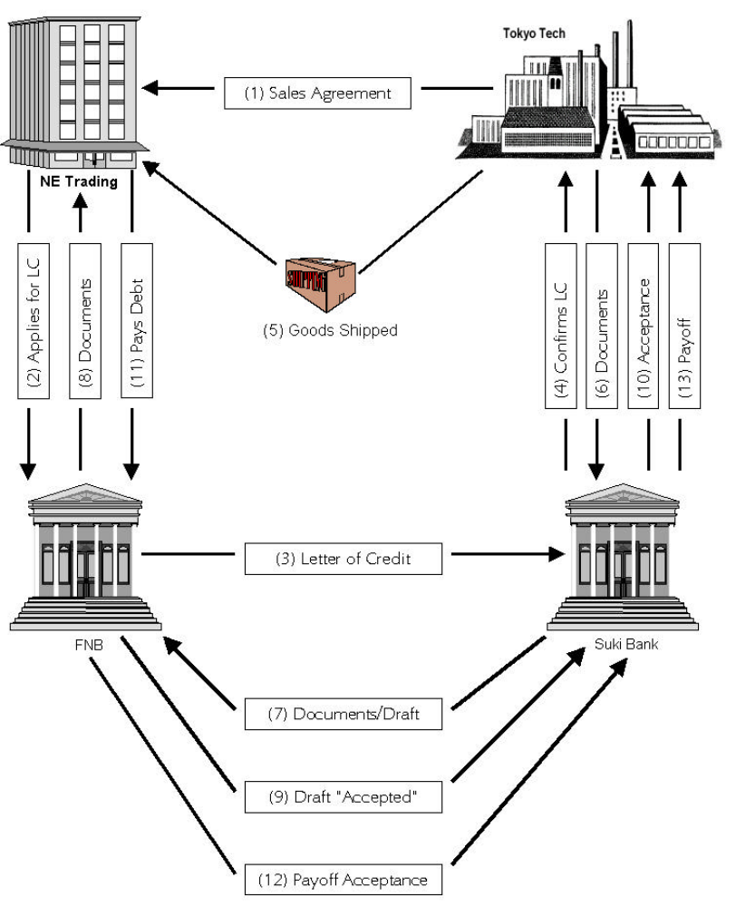

NE Trading is interested in purchasing 20 personal computers from Tokyo Tech. Since the two companies have never done business with each other, Tokyo Tech will require that NE Trading obtain a letter of credit. The letter of credit places the bank in the intermediary role to facilitate the completion of the transaction.

Here is how the process goes on,

- Tokyo Tech makes sales agreement with NE Trading initially and both parties decides upon the terms and conditions on the quality and quantity of the goods.
- NE Trading takes the computer purchase contract to its bank, FNB, and makes out an application for a letter of credit.
- FNB opens the letter of credit and sends the original and a copy to Tokyo Tech’s bank, Suki Bank.
- Suki Bank staff examines the letter of credit for validity and, upon verifying such, notifies Tokyo Tech. Since Tokyo Tech is not familiar with FNB, it pays a fee to have Suki Bank confirm the letter of credit, which makes Suki Bank liable should NE Trading and FNB fail to perform under the letter of credit.
- Now, Tokyo Tech ships the goods to NE Trading.
- Tokyo Tech presents the shipping documents to Suki Bank to have them negotiated. Along with the documents presented is a draft, drawn on FNB, for the selling price of the goods. (A draft is an unconditional written order signed by one person directing another person to pay a certain sum of money on demand or at a definite time to a third person or to the bearer.) In our example we are using a time draft. The terms of the draft are negotiated at the time the terms of the letter of credit are determined.
- Suki Bank examines the documents presented and, if they meet the terms and conditions of the letter of credit, it sends the draft and the shipping documents to FNB.
- FNB compares the documents with the letter of credit to ensure that they meet the terms and conditions stipulated in the letter of credit. If all is in order FNB furnishes NE Trading the documents, an advice of amount paid and “accepts” the draft.
- The term “accepted” is stamped on the face of the draft, thus creating a bankers’ acceptance.

By accepting the draft, FNB has accepted Tokyo Tech’s demand for payment and commits to pay Tokyo Tech in 90 days. The accepted draft is then sent to Tokyo Tech (through Suki Bank). As part of the letter of credit agreement NE Trading is required to pay FNB within the 90 days. The funds are then used by FNB to pay Tokyo Tech.

Tokyo Tech may hold the acceptance until maturity and present it to FNB for payment, or it may obtain immediate cash by selling the acceptance to an investor, perhaps to FNB or Suki Bank. In the latter case, Suki Bank would then present the acceptance at maturity to FNB for repayment.

When FNB accepted the draft in the example, it acquired an unconditional obligation to pay at maturity a specified amount, either to the Tokyo Tech or to the holder of the instrument if Tokyo Tech discounted the acceptance. If discounted, Tokyo Tech would remain secondarily liable to the holder (purchaser/discounter) of the acceptance in the event of default by FNB. If FNB purchases (discounts) its own acceptance, it may elect to hold the acceptance in its own portfolio. In this event, the acceptance is recorded as a loan to NE Trading and must be funded like any other loan. More commonly, however, the bank will elect to replenish its funds by selling (rediscounting) the acceptance in the secondary market, either directly or through a dealer. If the bankers’ acceptance is not held in portfolio, the bank records its obligation as “acceptances executed.”

Associated Risks

- Credit Risk (In the example given above, if the computer prices goes down by the time shipment comes to NE trading. It might not pay to the FNB and hence there are chances of credit risk.)
- Liquidity risks (as the banker acceptance is traded in market, it might happen that there are less demand for banker’s acceptance and hence it is very difficult to liquidate it.)
- Inflation Risk (As the payment comes after 90 days, there are chances that inflation goes up. E.g. suppose after 90 days the computer price substantially goes up that can create a big opportunity loss to FNB.)
- Market volatility (as the banker’s acceptance is traded in market, market volatility perform the major role in the price of it)

References

http://en.wikipedia.org/wiki/Bankers'_acceptance
http://www.fiscalagents.com/knowledge/inforeport/ba.shtml
http://www.investopedia.com/university/moneymarket/moneymarket5.asp
http://en.wikipedia.org/wiki/Bankers'_acceptance

RoyFarm Mortgage Multiple Loan

Brief Overview

- Roy Farm Mortgage Multiple Loan Option has been designed for the agricultural market. This innovative mortgage product is targeted at growth-oriented clients who require flexible financing terms to purchase land, construct fixed structures, purchase quota, purchase equipment and restructure debt.
- Multiple Loan Option allows clients to create multiple loans secured with one mortgage document
- The mortgage they require may be for one or more of the four specific purposes listed below:
  - Expansion of the present land base through acquisition of additional land.
  - Development of present land holdings through larger scale land improvement projects (land clearing, irrigation, tiling, etc.) or through the addition of large scale permanent building structures requiring financing on a longer term basis.
  - Consolidation of short and intermediate term debts on a selective basis through refinancing over an extended period.
  - Re-use of equity built up in mortgage able assets to finance the purchase of a shorter term asset over an extended period of time.

Targeted Customers
Agriculture and Agri Business clients

Features
- Customer can create multiple loans with one mortgage document as security.
- Interest rate charged could be Variable rate or fixed rate with 1, 2, 3,4,5,7 & 10 year.
- Loans can be advanced in stages over 18 months from the original approval date.
- Payment frequencies for each loan can be weekly, bi-weekly, semi-monthly, monthly, bi-monthly, quarterly, semi-annual or annual.
- After partial pay down Add-On proceeds can be borrowed up to the original aggregate principal amount of the mortgage.

Benefits
- It leverages your mortgage by providing you with a series of smaller loans each with their own features designed to support specific farm needs so a borrower can customize mortgage by amortizing each individual purchase over its true useful life (e.g. land over 20 years, buildings over 15 years, quota over 5 years).
- Each loan can have different interest terms, payment frequencies and amortization schedules at either fixed or variable rates to help manage fluctuating interest rates and cash flow requirements so the borrower can manage interest rate risk by selecting different interest rate terms for each loan allowing the client to stagger the maturity of their loans over the interest rate cycle.
- Client pays less interest by drawing/advancing funds as needed (e.g., during a construction project).
- Mortgage payments match cash flow.
- Client can borrow funds up to the original aggregate principal amount of the mortgage using the original mortgage document, thereby saving legal costs.

RBOL

Purpose of the Loan
Purpose of this loan is to provide access to additional funds through business deposit account with a credit line starting at $5,000 that will give the financial flexibility to support business growth.

Description of Loan

RBOL basically is a operating credit line for business ( in other word you can say it is a “RCL version for business”)
Royal Business Operating Line supplements the cash flow by providing a business with a line of credit that is accessible 24 hours a day through a wide variety of channels.

Business can access these funds anywhere, and at anytime, through ABMs, Online and Telephone Banking, and through your Client Card at branches or through Interac.

Business can opt for “Automatic Transfer” wherein automatically checking loan and deposit account balances every business day and paying down credit line with any surplus funds happens. So business doesn’t need to put any effort to manage credit line.

The interest paid on your Royal Business Operating Line is based on the Royal Bank Prime rate plus a premium depending on your credit history.

Benefits of RBOL

If you need short-term funds, an operating loan will help you take advantage of supplier discounts/Cash Discount for prompt payment. The loan is granted based on your needs and changes with them.

Probably you are out of money at any business cycle and probably you are excess of money at some point of time.
You might want to make some capital purchase and same time you have some fixed expenditure (like salaries of employees etc) coming up.

All those time you might want short term fund. And probably such unseen situations occur frequently in your business.

In those times you can always enjoy the convenience and flexibility of a credit line where you can use credit line for large capital purchases or simply everyday business purchases, anything anytime with lots of channel to access fund.

Apart from that you can always have “automatic transfer flexibility” described as above, so you can concentrate more on your core business.

Eligibility

- Client must operate a CAD Business Deposit Account
- RBOL is not available in USD
- RBOL cannot be added to account with existing Royal Business Overdraft Protection (RBOD)
- RBOL not permitted on Staff, Internal, High Volume, Trusteed, NISA or Cash Contra Accounts
- Minimum limit $5000.00

Rate of Interest and Other Charges

- The interest paid on your Royal Business Operating Line is based on the Royal Bank Prime rate plus a premium depending on client’s credit history.

- Low monthly fee of $15 for the credit line is charged.

- Automatic transfer of surplus deposit balances to your outstanding credit line is chargeable at additional $10 per month.

Additional Information

- RBOL permits access to Automated Teller Machines (ATM), Online Banking, Royal Direct, Telephone Banking and Point of Sale (POS)

- RBOL activity and balance is available for viewing online.

- RBOL will not respond to a request Online for transfer of funds from attached account to USD account. But the same can be done as below:

  - Transfer from RBOL to attached CAD C/A
  - Then transfer from CAD C/A to USD C/A

- RBOL does not close automatically when at a $00.00 balance.

- RBOL statements will be produced monthly and are cycled to match account statement date.

Referance

http://resources.canadianbeefbreeds.com/loan-products-royal-bank-of-canada
http://www.rbcroyalbank.com/commercial/financing/operating-lines-of-credit.html
http://www.rbcnet.fg.rbc.com/royaldirect/bb/cid-98678.html#top
http://rbcnet.fg.rbc.com/gto/contactcentres/eac/bbts/cid-113787.html
http://ezinearticles.com/?Benefits-of-a-Secured-Line-of-Credit&id=1415592

10. Government Guaranteed Loan

10.1 Definition

Government guaranteed loans are one of the most popular lending program types as people or organizations who are otherwise not qualified to take on loans from banks and other lending institutions, can qualify for these programs as long as part of the group or sector is the intended beneficiary of the program. It helps businesses to receive a government guaranteed loan from a financial institution for capital expenditures and working capital for the establishment, expansion or maintenance of your business.

10.2 Eligibility Criteria

Applicants seeking a loan guarantee will be required to demonstrate through submission of a comprehensive Business Plan, that their project is viable, will contribute to the economic growth of the province and that the company has the financial capacity to repay its loan according to the Terms and Conditions and within the prescribed time period. Additionally, the applicant will be required to demonstrate that the required funding would not otherwise be available on reasonable terms and conditions.

A government guaranteed bank usually facilitates loan and lending institutions designated by the government agencies. The idea is that people or organizations that are qualified for such a loan program, approach banks and lending institutions that are affiliated with the program and fill out the application form provided for them there. There are sets of standards and qualifications specified for particular government guaranteed loan programs, so it is imperative that for a person or organization to be able to get a guaranteed loan, they must meet all the requirements and qualifications.

10.3 Types of GGL

There are many government guaranteed loan programs being offered on the market nowadays. Some of the most popular government guaranteed loan programs are student loan programs, the small business guaranteed loan programs, the veteran's guaranteed loan programs and the agricultural guaranteed loan programs. Accordingly, under these programs, the government pledges to purchase the unpaid loan from the bank or lending institution in the event where the borrower fails to pay the loan on the due date. These loan programs are intended for those people who do not have enough collateral available to qualify for secured loans.

. Loans to Cities, Towns, Municipalities, etc

11.1 Definition

Loans to any city, town, incorporated improvement district and even unincorporated districts administered by a province for renewal of a municipal waterworks system, municipal gas plant, municipal electric light system, or other municipal project. But these loans are given provided the project is a self liquidating one .i.e. it will earn money sufficient to pay the loan. Under these terms a sports complex, which was designed to charge for use until the loan was paid off, would qualify, or a sewer line, if it was to be paid for by a levy on the users, and provided that the government of the Province backs the loan.

*** No other information available.

12. New Term Loan

Eligible businesses include corporations, partnerships, sole ownerships, individuals, non-profit organizations and joint ventures, with an acceptable Borrower Risk Rating (3+ or better).

*** No further information is available as of December-2010

13. FSHDMD – Independent Fisherman Demand

This is a business demand loan given to Commercial Fisherman with principal paid yearly and interest paid monthly.

*** No further information is available as of December-2010
14. Grain Canadian WHT
Grain Canadian WHT is a business demand loan product of RBC.

*** No further information is available as of December-2010

15. Grain other

Grain other is a business demand loan product of RBC.

*** No further information is available as of December-2010.

